Chemistry Questions and Answers
Name
Institutions

- a) Using the online periodic table, identify what family the following elements are in (4 marks: 1mark for each)
Element | Family
Sodium | Alkali Metals
Fluorine, chlorine | Halogens
Nickel, copper, zinc | Other metals
Beryllium, magnesium | Alkali Earth metal

b) Indicate two ways that you can tell if an element is a metal or non- metal
Metals
1. Metals are solids at room temperature except mercury
2. metals can conduct heat and electricity
Non-metals
- Do not conduct electricity
- Can be solid, liquid pr has at room temperatures.
25. a) indicate whether each of the following elements is likely to transfer (T) electrons or share (s) electrons when combining with Sulphur
Element | Electron: transfer or share (T or S)
Lithium | T
Fluorine | S
Nitrogen | S
magnesium | T

b. Explain why atoms get together to form compounds
Atoms tend to form chemical bonds in order to make the outer electron shells more stable.
26. fill in the blank sections of this concept map to correctly relate the following matter;
Matter, ionic compounds, molecular compounds, atoms
Matter is composed of atoms which can form ionic compounds or which can form molecular compounds.
27 using the periodic table, write the name of the following compounds
Compound | Name
LiBr | Lithium Bromide
Na₂O | Sodium oxide
NO₂ | Nitrogen iv Oxide
CO₂ | Carbon iv Oxide
CaF₂ | Calcium fluorid

28. For each of the following reactions, state whether a physical or chemical change has occurred. Give evidence for your answer.
a. a silver solid is dropped into a clear and colorless solution. After a few minutes, small bubbles are seen coming from the silver solid – chemical change
When the silver solid is placed into the clear solution it forms bubbles which points to the production of a new gas.

b. a yellow solid is broken and ground into a fine powder – Physical change. This is because it did not undergo any change in the substance but only a change in its state
c. small, white crystals are added to a beaker of water, which is stirred until the crystals disappear- physical change
This is because when the crystals dissolve into the water, it seems to have changed, but if the water is evaporated, the crystals can be recovered.
d. a clear and colorless solution turns pink when few drops of colorless solutions are added- chemical change
This is because when two colorless liquids mixed together and have a different color, its most likely to be a chemical reaction. When you add blue to a water for instance, it’d turn blue and it wouldn’t be a chemical reaction because blue isn’t a new color.
e when a wooden splint is heated, it ignites into flames and then burns- chemical change
Because a wooden splint turns into ash while burning.
29. Write the proper chemical name for each of the following compounds. If necessary, look up the element names for the symbols in the periodic table.
Formula | Chemical name | formula | Chemical name
LiCl | Lithium Chloride | Al₂(SO₄)₃ | Lithium Chloride
KBr | Potassium Bromide | BeS | Beryllium Sulphide
CaF₂ | Beryllium Sulphide | SO₃ | Sulphur Dioxide
ZnCl₂ | Zinc Chloride | NO₂ | Nitrogen Dioxide
Ca(NO₃)₂ | Zinc Chloride | PCl₅ | Phosphorus Pentachloride
30. write the proper chemical formula for each of the following compounds. If necessary, look up the element names for the symbols in the periodic table.
Chemical Name | formula | Chemical Name | formula
Calcium Chloride | CaCl2 | Sodium nitrate | NaNO3
Sodium Chloride | NaBr | Potassium Sulphate | K2SO4
Potassium Sulphide | K2S | Calcium carbonate | CaCO3
Dihydrogen Sulphide | H2S | Magnesium Sulphate | MgSO4
Nitrogen dioxide | NO2 | Sodium acetate | C2H3NaO2

31 in one sentence, describe a single displacement reaction
Single displacement reaction occurs when one atom takes the place of another compound in the formula.
32 for each of the reactions below, identify the type of the reaction (Synthesis, decomposition, single displacement, or double displacement
- 2H2O2 2H2 + O2
Décomposition
B) N2H4 +O2 2H2O+N2
synthesis
C) 3CuCl2 + 2Al 3Cu + 2AlCl3
single displacement
D) N2 + 3H2 2NH3
synthesis
E) Pb(NO3)2 + 2KI PbI2 + 2KNO3
double displacement
F) Ca + 2H2O Ca(OH)2 + H2
single displacement
G) 2NaBr + Pb(NO3)2 2NaNO3 + PbBr2
double displacement
H) CaCO3 CaO + CO2
Décomposition
I) 2Li + 2H2O 2LiOH + H2
single displacement
j) Mg + 2HCl MgCl2 + H2
single displacement

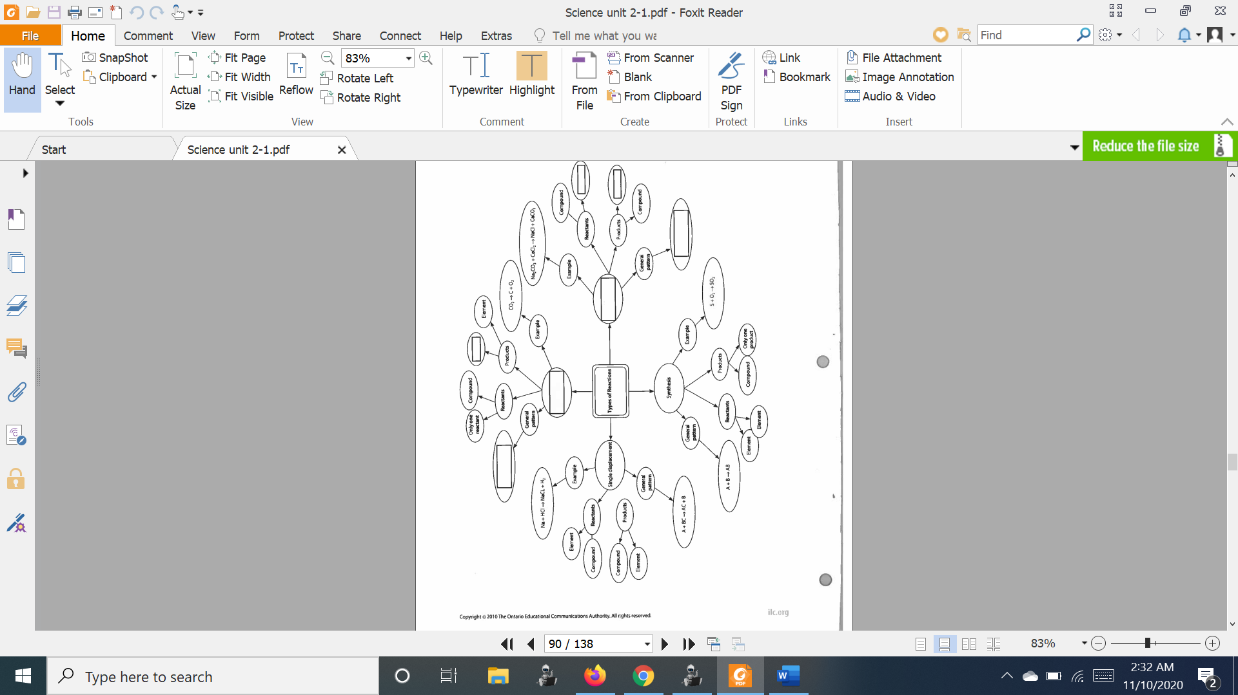
33 the partially filled concept map on the next page summarizes the differences among single displacement, double displacement, synthesis, and decomposition reactions. Fill in the seven shaded boxes with the correct information
The top one: decomposition
General pattern of decomposition
is AB ----> A + B.
Products are element and element.
2. The right one:
double displacement.
General pattern:
AB + CD ----> AD + CB
Reactants: Compound and Compound
Products: Compound and compound.
34 use the law of conservation of mass to calculate the expected mass of the product in the following reaction of 120g of calcium reacts with 96g of oxygen gas.
Ca+O₂ CaO
Write a sentence to explain your answer
A balanced equation becomes 2Ca + O2 ----> 2CaO
35 balance each of the following reactions
- 4Fe + 3O₂ 2Fe₂O₃
- 3CuCl₂+ 2Al 3Cu+ 2AlCl₃
36. for each of the following word equations write a balanced chemical equation
a. beryllium chloride reacts with aluminum nitrate to produce beryllium nitrate and aluminum chloride
3BeCl2 + 2Al(NO3)3 --> 3Be(NO3)2 + 2AlCl3
- Sulphur burns in oxygen to produce Sulphur dioxide
S+ O 2 —> SO₂
37. given the reactions Zn(OH)2 + AlCl3 ZnCl2 + Al (OH)3
a. Explain in a sentence or two why it is considered balanced
The equation is not balanced because the amounts of specific elements are not the same on both sides. Every element has specific number of atoms. On reactant side we have Zinc - 1 (atoms), Oxygen - 2 (atoms), Hydrogen - 2 (atoms),Aluminum - 1(atoms), Chlorine - 3 (atoms) and on the product side we have Zinc - 1, Oxygen - 3, Hydrogen - 3 ,Aluminum - 1, Chlorine - 2 . As we can see they are not the same.
b. Write a series of steps to explain how it would be balanced.
- Write the chemical reaction using proper chemical formula.
- Make a small table to summarize how many atoms of each element you have on the reactant side and on the product side.
- Identify a chemical that needs to be balanced
- Add a whole number to the front of the chemical formula in the reaction.
- Apply that change to all the atoms in the formula and update the table.
- Continue to identify elements that need to be balanced and write the appropriate whole number in the reaction, then apply the change and update the table.
- When each atom is equal on both sides of the table, then you have balanced the reaction.
38. acids and bases can be identified in different ways. In complete sentences explain how acids and bases can be distinguished from each other using the following
a. physical properties
Acids and bases can be identified as a physical property, like taste, acids taste sour and bases taste bitter
b. chemical properties
Acids and bases can be identified as a chemical property, like chemical changes. For instance: acids turn litmus paper red and react with metal, while bases turn litmus paper red.
- names and formulas
Acids and bases should not be tasted rather, they can be identified through names and formulas. For instance, we can identify them by PH, acids have a PH <7 and bases pH>7
39. Write word and balanced equation to represent the reaction between the following pairs of substances
a. magnesium and hydrochloric acid
Mg(s) + 2 HCl(aq) --> MgCl ₂(aq) + H ₂(g)
- calcium and sulphury acid
H_2SO_4(aq) + Ca(OH)_2(s) --> CaSO_4(s) + 2H_2O
- hydrochloric acid and sodium hydroxide
NaOH + HCl = NaCl + H2O
40. complete the following table by providing names or formulas as required.
Name | formula | Name | formula
Ammonia | NH₃ | Phosphoric acid | H₃PO₄
Hydrogen sulfide | H2S | Magnesium Hydroxide | Mg(OH)₂
Calcium Hydroxide | Ca(OH)2 | hydrogen chloride | HClO3
Potassium Hydroxide | KOH | Ethylene Glycol Molar Mass | HC2H5O2
41. In complete sentences, describe one example of an acid used around the home and example of base used around the home.
Vinegar. It contains acetic acid. People use it at home for cooking. It can remove mold and mildew on surfaces like tiles and glasses.
Home cleaning powders. They have effects on metals and other surfaces. Examples of base cleaning powders include detergent powders, bathroom cleansers and bleaches
42 list four categories of dangerous materials used on the WHMIS system
1. Compressed Gases.
2. Flammable and Combustible Materials.
3.Oxidizing Materials.
4.Poisonous and Infectious Materials
43. describe two ways chemistry can be used to solve the acid precipitation problem. In your answer, refer to a specific aspect of the problem
Acid rain . To solve this problem people, need to reduce Sulphur and nitrogen emissions. There are two main stages to handle it, it requires energy producers to clean smokestacks with scrubbers that trap pollutants before they are released into the atmosphere and to reduce car emissions with catalytic converters.
44 in a car engine, gasoline (C8H18) is burned in oxygen (O₂) to create energy. The normal products are carbon dioxide and water. However, gasoline is a mixture that also contains some Sulphur and nitrogen compounds. When the gasoline is burned, compounds called Sulphur oxides such as SO₂ and SO₃ and Nitrogen Oxides such as NO, NO₂ and N₂O₅ are formed. These compounds are pollutants that contribute to poor air quality and environmental problems such as precipitation. Take the position of an environmentalist and suggest three ideas that you could propose to the government to reduce the amount of air pollution formed.
Solution
- Make the engine more efficient so that you get more miles per gallon and therefore burn less gasoline.
- Refine the gasoline to remove the Sulphur and nitrogen compounds so that they are not present when the fuel is used.
- Encourage the development and use of alternate fuels that do not emit these pollutants.

